**Project Design Phase-II**

**Data Flow Diagram & User Stories**

|  |  |
| --- | --- |
| Date | 08March 2025 |
| Team ID | SWTID1741328203147747 |
| Project Name | Cryptoverse Dashboard |
| Maximum Marks | 4 Marks |

**Data Flow Diagrams:**

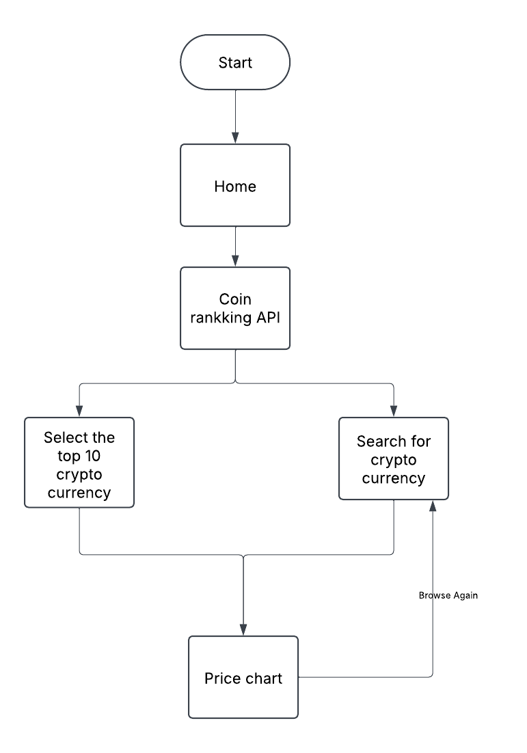A Data Flow Diagram (DFD) is a traditional visual representation of the information flows within a system. A neat and clear DFD can depict the right amount of the system requirement graphically. It shows how data enters and leaves the system, what changes the information, and where data is stored.

**User Stories**

| **User Type** | **User Story Number** | **User Story / Task** | **Acceptance criteria** | **Priority** | **Release** |
| --- | --- | --- | --- | --- | --- |
| Customer  (Web user) | USN-1 | As a user, I can search for crypto currencies, Price chart | I can access crypto dashboard | High | Sprint-1 |
| Customer  (Web user) | USN-2 | As a user, I can view trending and top 10 crypto coins on home page | I can view information about the top 10 crypto currencies without limit | High | Sprint-1 |
| Customer  (Web user) | USN-3 | As a user, I can view the Crypto currencies | I can view all the crypto currencies of all the kinds | Low | Sprint-2 |